157.1

#include <stdio.h>

int main()

{

int count;

count=2;

while(count<=10)

{

printf("%d ",count);

count+=2;

}

return 0;

}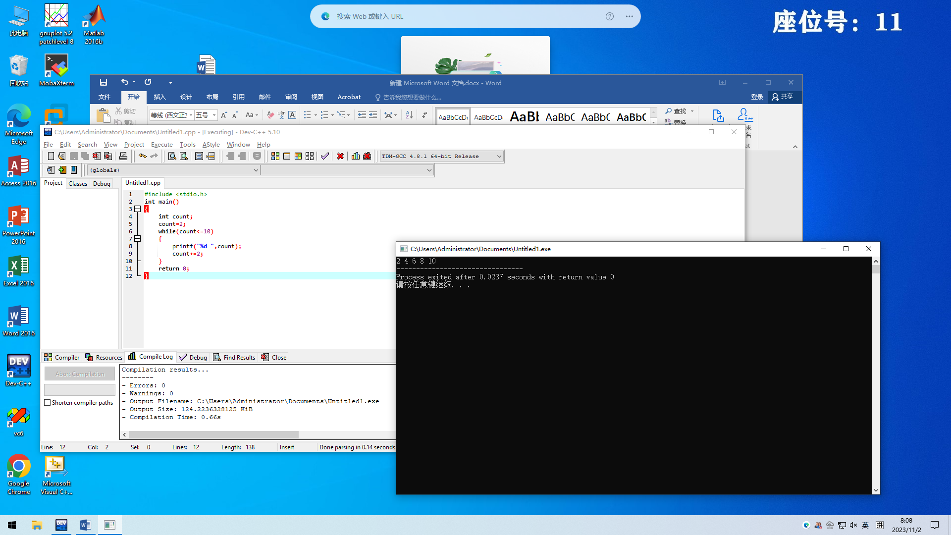

157.3

#include <stdio.h>

int main()

{

int gallons;

float liters;

gallons=10;

while(gallons<=20)

{

printf("Gallons:%d\n",gallons);

liters=gallons\*3.785;

printf("Liters:%f\n",liters);

gallons++;

}

return 0;

}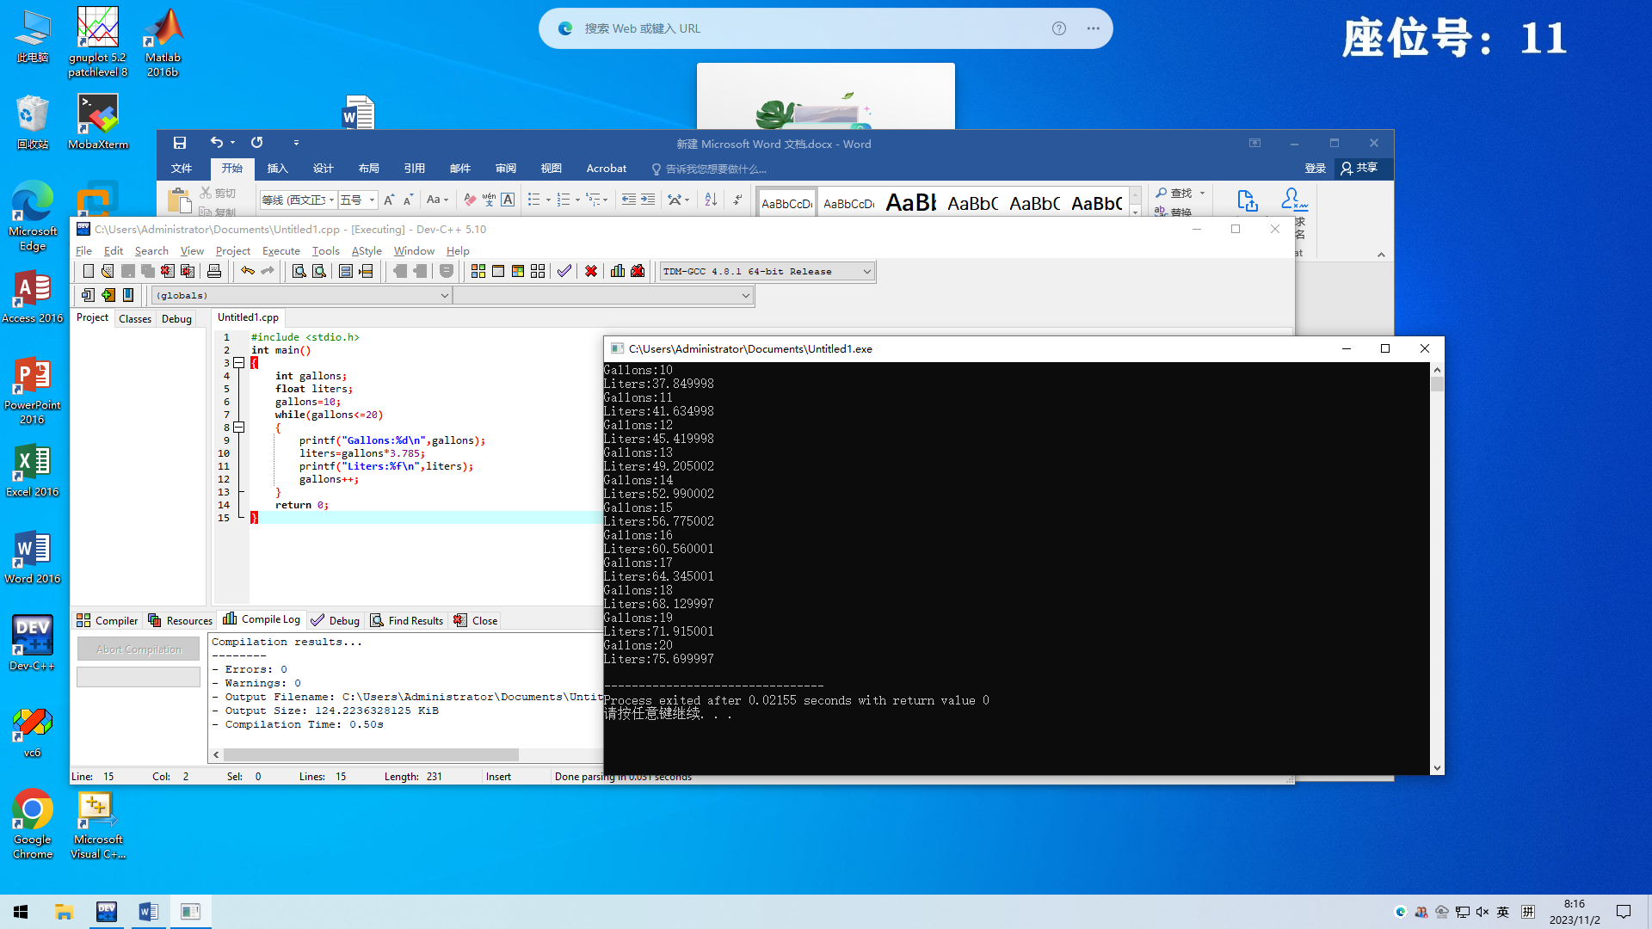

166.6

#include <stdio.h>

int main()

{

int total,number;

number=1;

float num,all,average;

all=0;

printf("Please type in the total number of data values to be avergaed:");

scanf("%d",&total);

while(number<=total)

{

printf("Enter the number:\n");

scanf("%f",&num);

all=all+num;

number++;

}

average=all/total;

printf("Average is:%f",average);

return 0;

}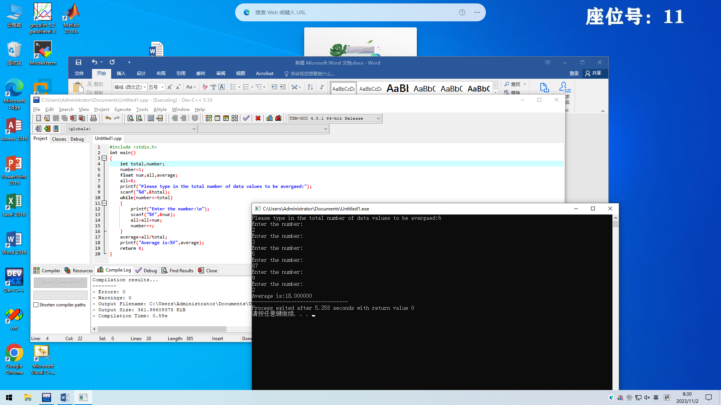

166.8

#include <stdio.h>

int main()

{

int count,id,inventory,received,sold,updated;

count=1;

updated=0;

while (count<=3)

{

printf("Enter the id,inventory at the beginning,number of copies received and sold:\n");

scanf("%d %d %d %d",&id,&inventory,&received,&sold);

updated=inventory+received-sold;

printf("The book id number:%d",id);

printf("\nThe new balance:%d\n",updated);

count+=1;

}

return 0;

}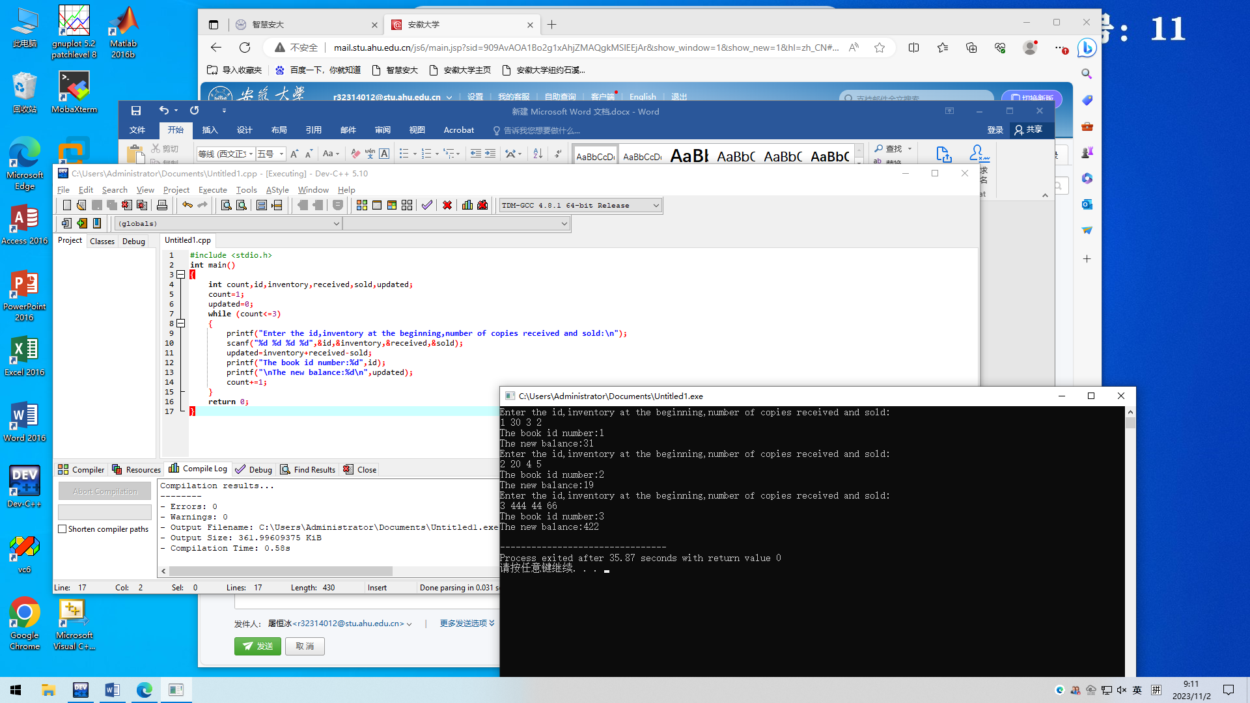

174.6

#include <stdio.h>

int main()

{

int year=1;

float money=1000.0,rate=0.08;

while (year<=10)

{

money=money\*(1+rate);

printf("This year's amount:%f\n",money);

year++;

}

return 0;

}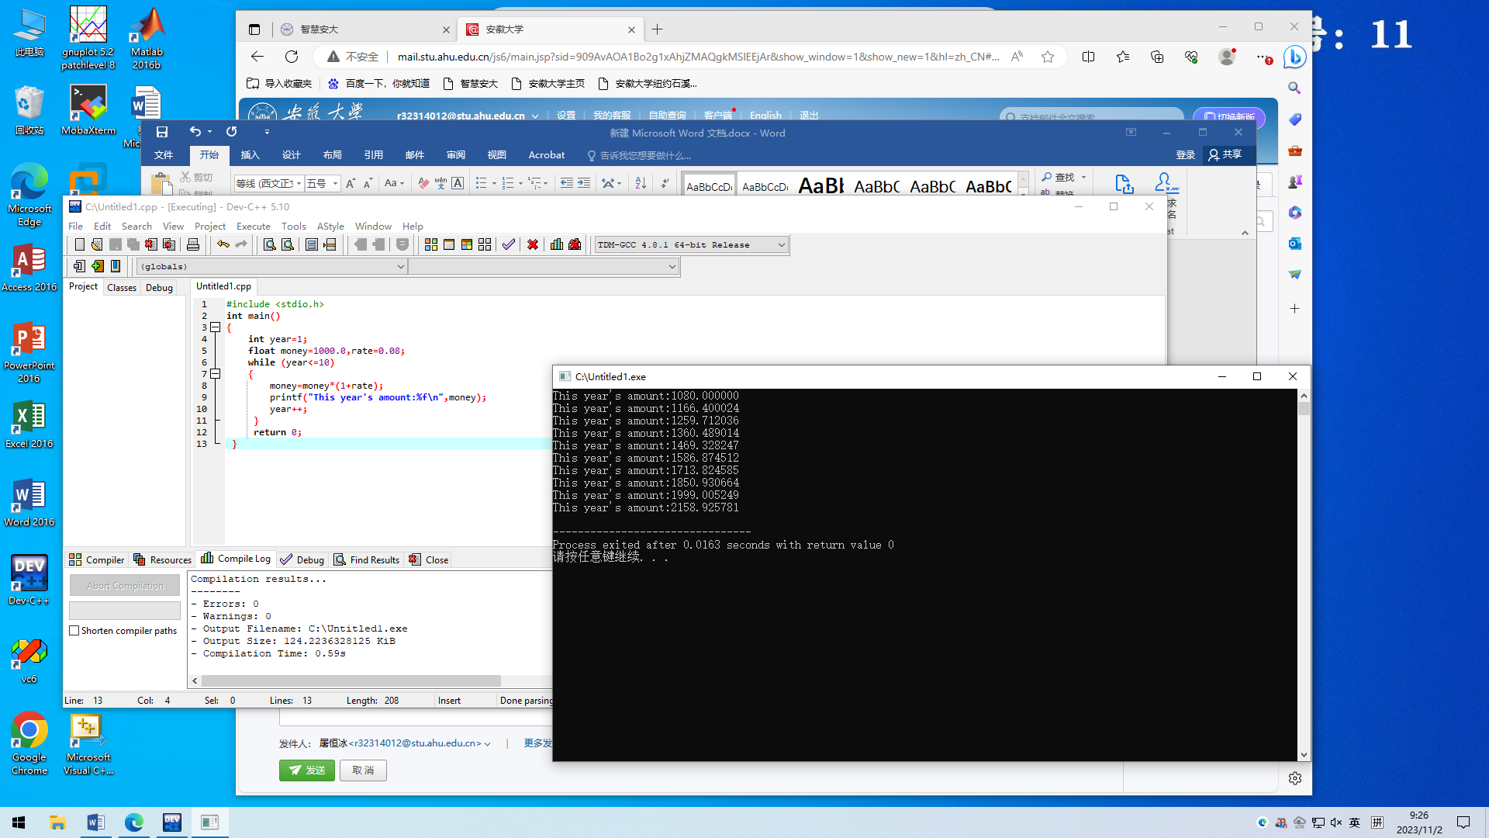

174.7

#include <stdio.h>

int main()

{

int year=0,depreciation=4000,value=28000,ad;

printf(" DEPRECIATION SCHEDULE\n ---------------------\n");

printf(" END-OF-YEAR ACCUMULATED\n");

printf("YEAR DEPRECIATION VALUE DEPRECIAITON\n");

printf("---- ------------ ----------- ------------\n");

while(value>0)

{

year++;

value-=depreciation;

ad+=depreciation;

printf("%d %8d %14d %16d\n",year,depreciation,value,ad);

}

return 0;

}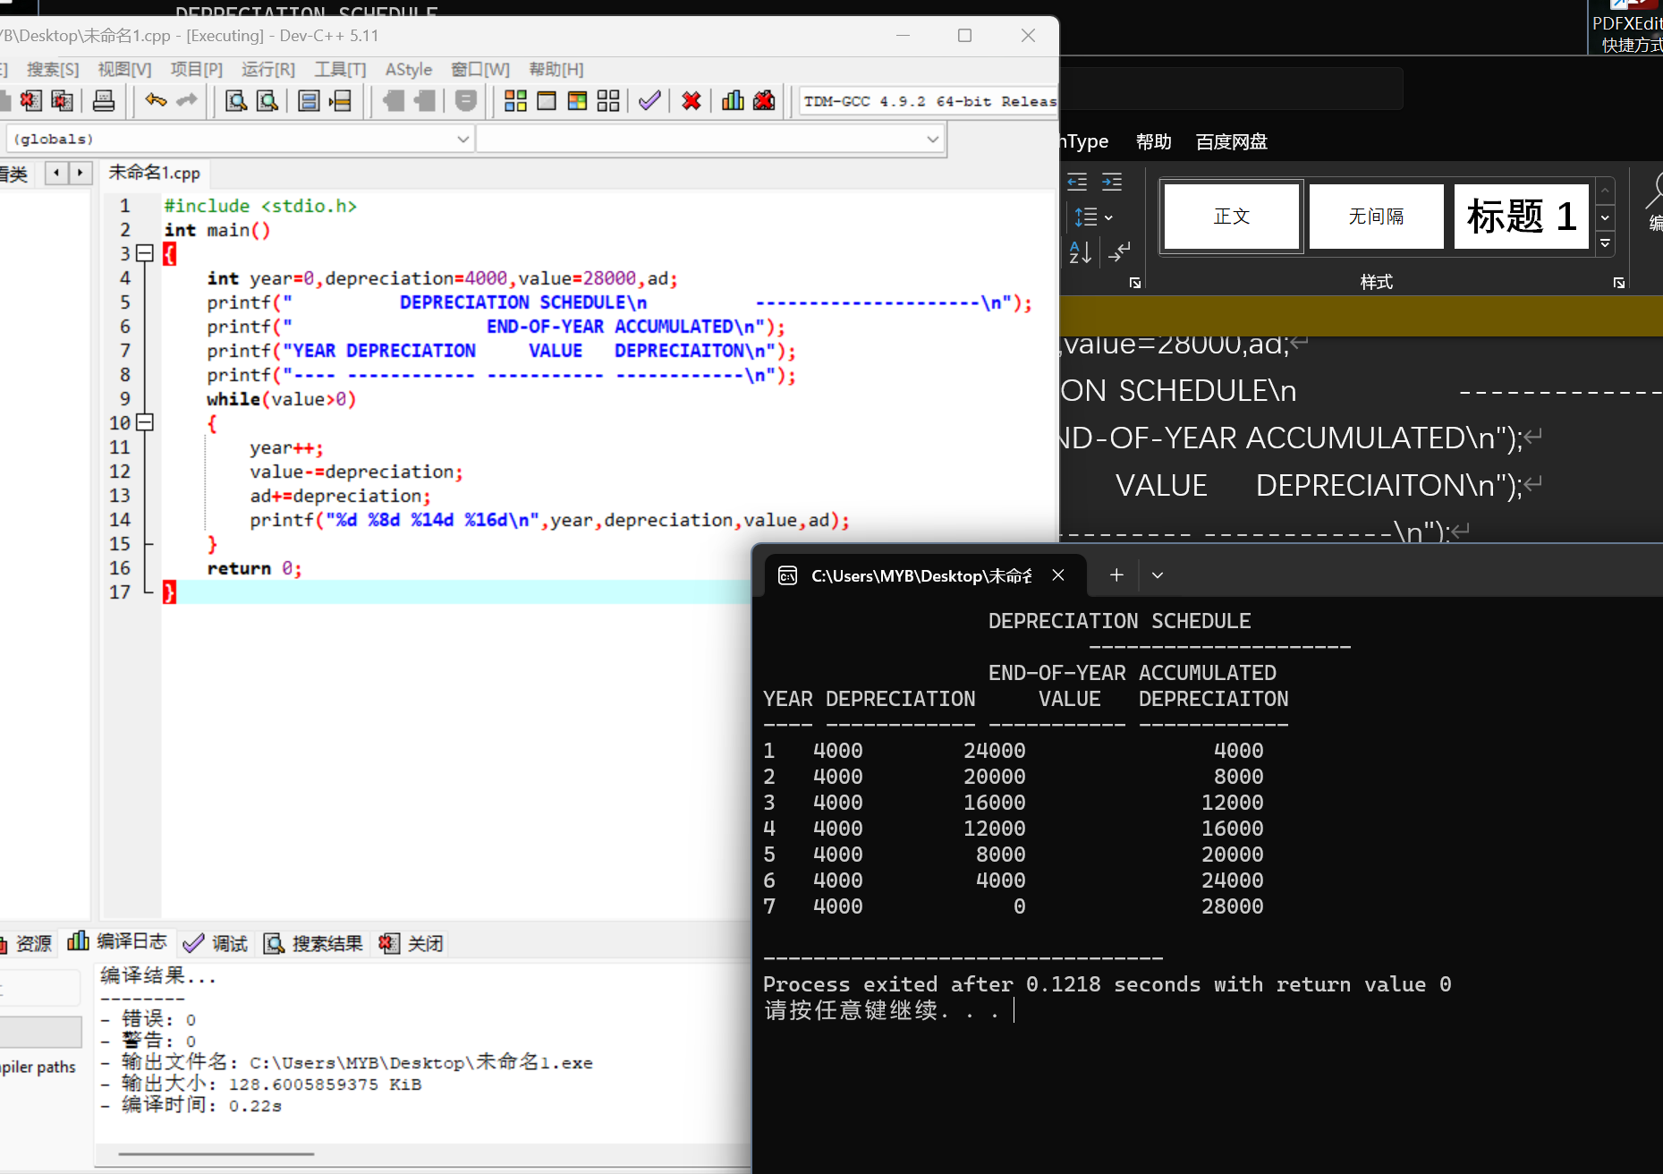

174.8

#include <stdio.h>

int main()

{

int year=0;

float sales=10000000,profit=sales\*0.1,rate=0.04;

printf(" SALES AND PROFIT PROJECTION\n");

printf(" ---------------------------\n");

printf("YEAR EXPECTED SALEES PROJECTED PROFIT\n");

printf("---- --------------- ----------------\n");

while(year<=10)

{

year++;

printf("%3d $%11.2f $%10.2f\n",year,sales,profit);

sales=sales\*(1-rate);

profit=sales\*0.1;

}

printf(" --------------- ---------------\n");

printf("Totals: $ $");

return 0;

}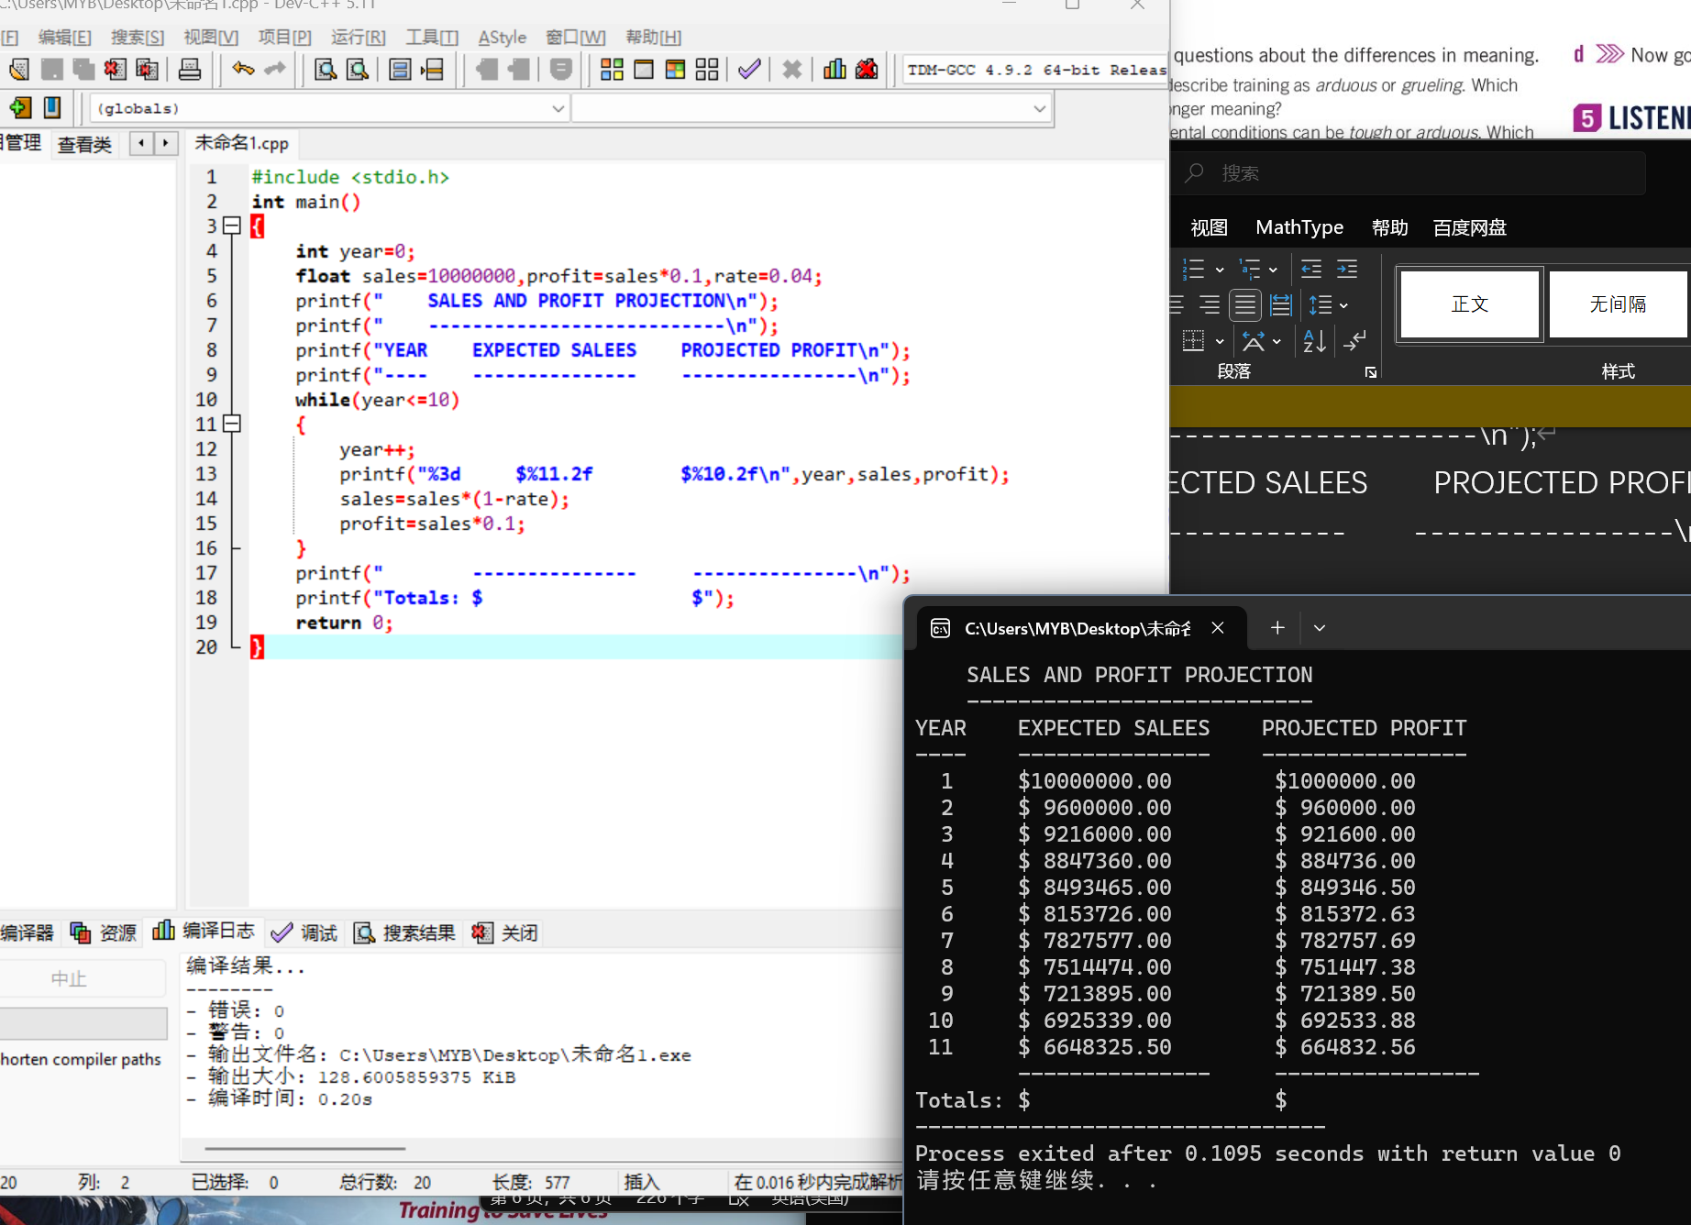

180.5

#include <stdio.h>

int main()

{

int month,day;

printf("Enter the month:");

scanf("%d",&month);

printf("Enter the day:");

scanf("%d",&day);

if (month<=12&&month>=1)

{

switch(month)

{

case 2:

if(day>=1&&day<=28)

printf("Good!");

else

printf("The day is wrong!");

break;

case 4:case 6:case 9:case 11:

if(day>=1&&day<=30)

printf("Good!");

else

printf("The day is wrong!");

break;

default:

if(day>=1&&day<=31)

printf("Good!");

else

printf("The day is wrong!");

break;

}

}

else

printf("The month is wrong!");

return 0;

}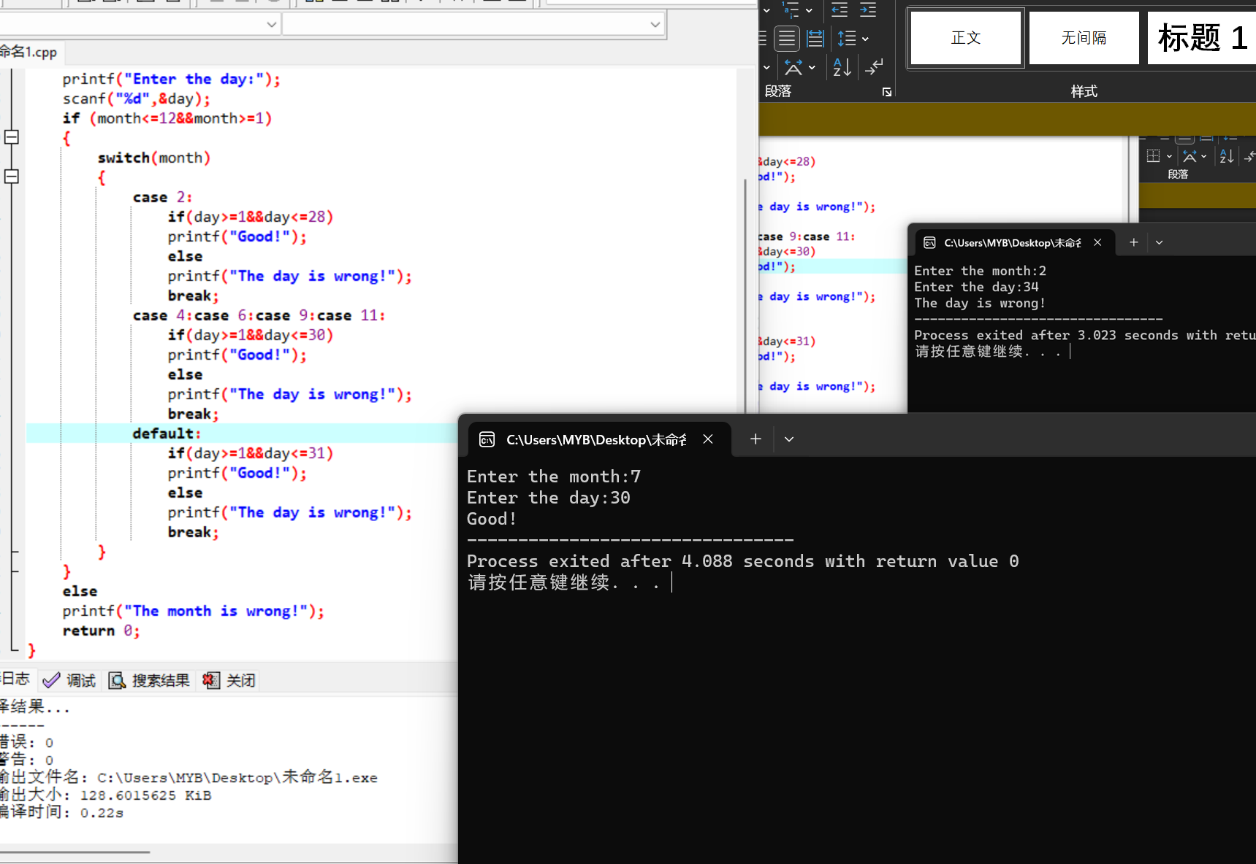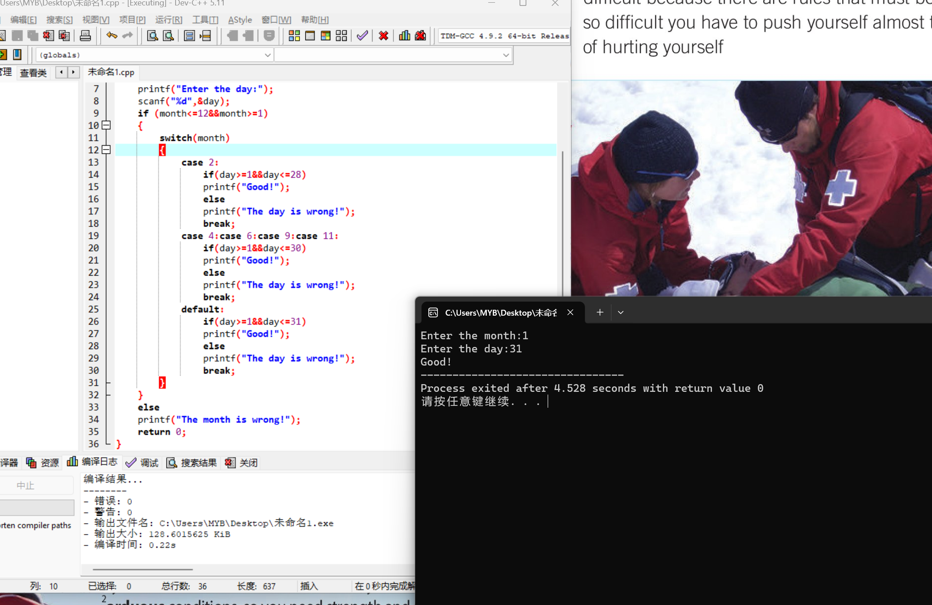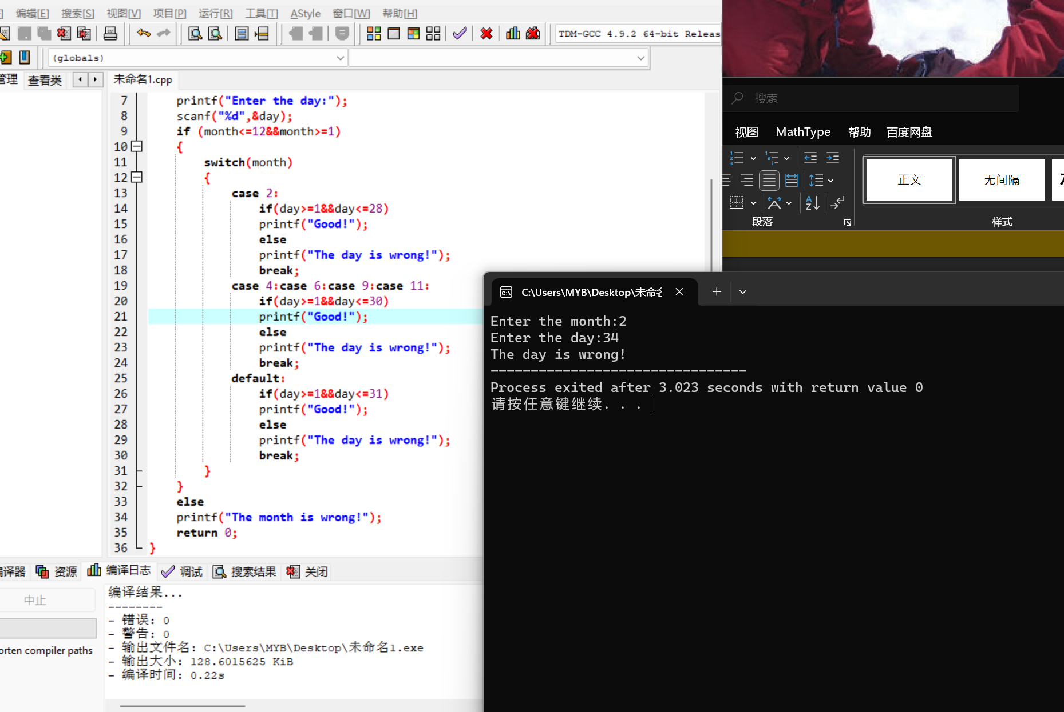

180.6

#include <stdio.h>

int main()

{

int position,num,max,still;

for(position=1;position<=5;position++)

{

printf("Enter the number:");

scanf("%d",&num);

if(num>max)

{max=num;

still=position;}

}

printf("The maximum number is:%d\n",max);

printf("The position is:%d",still);

return 0;

}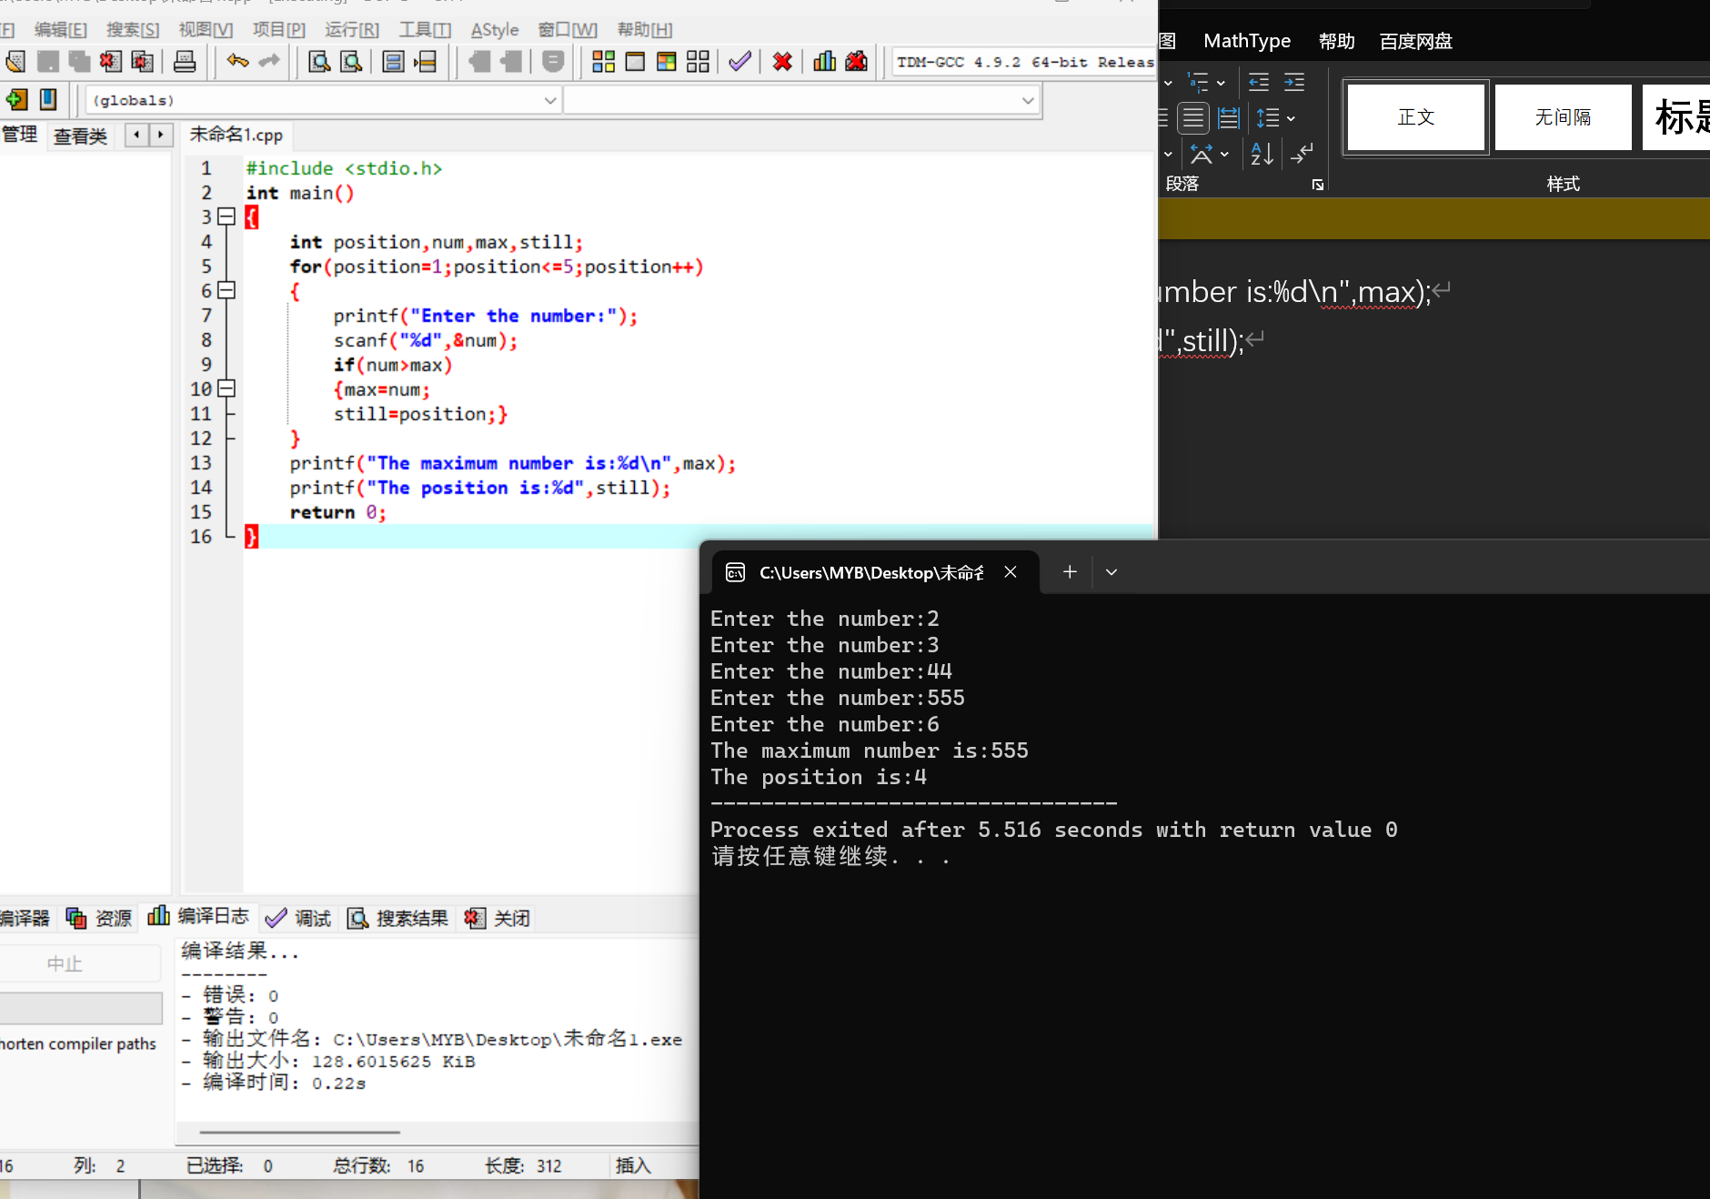

b.

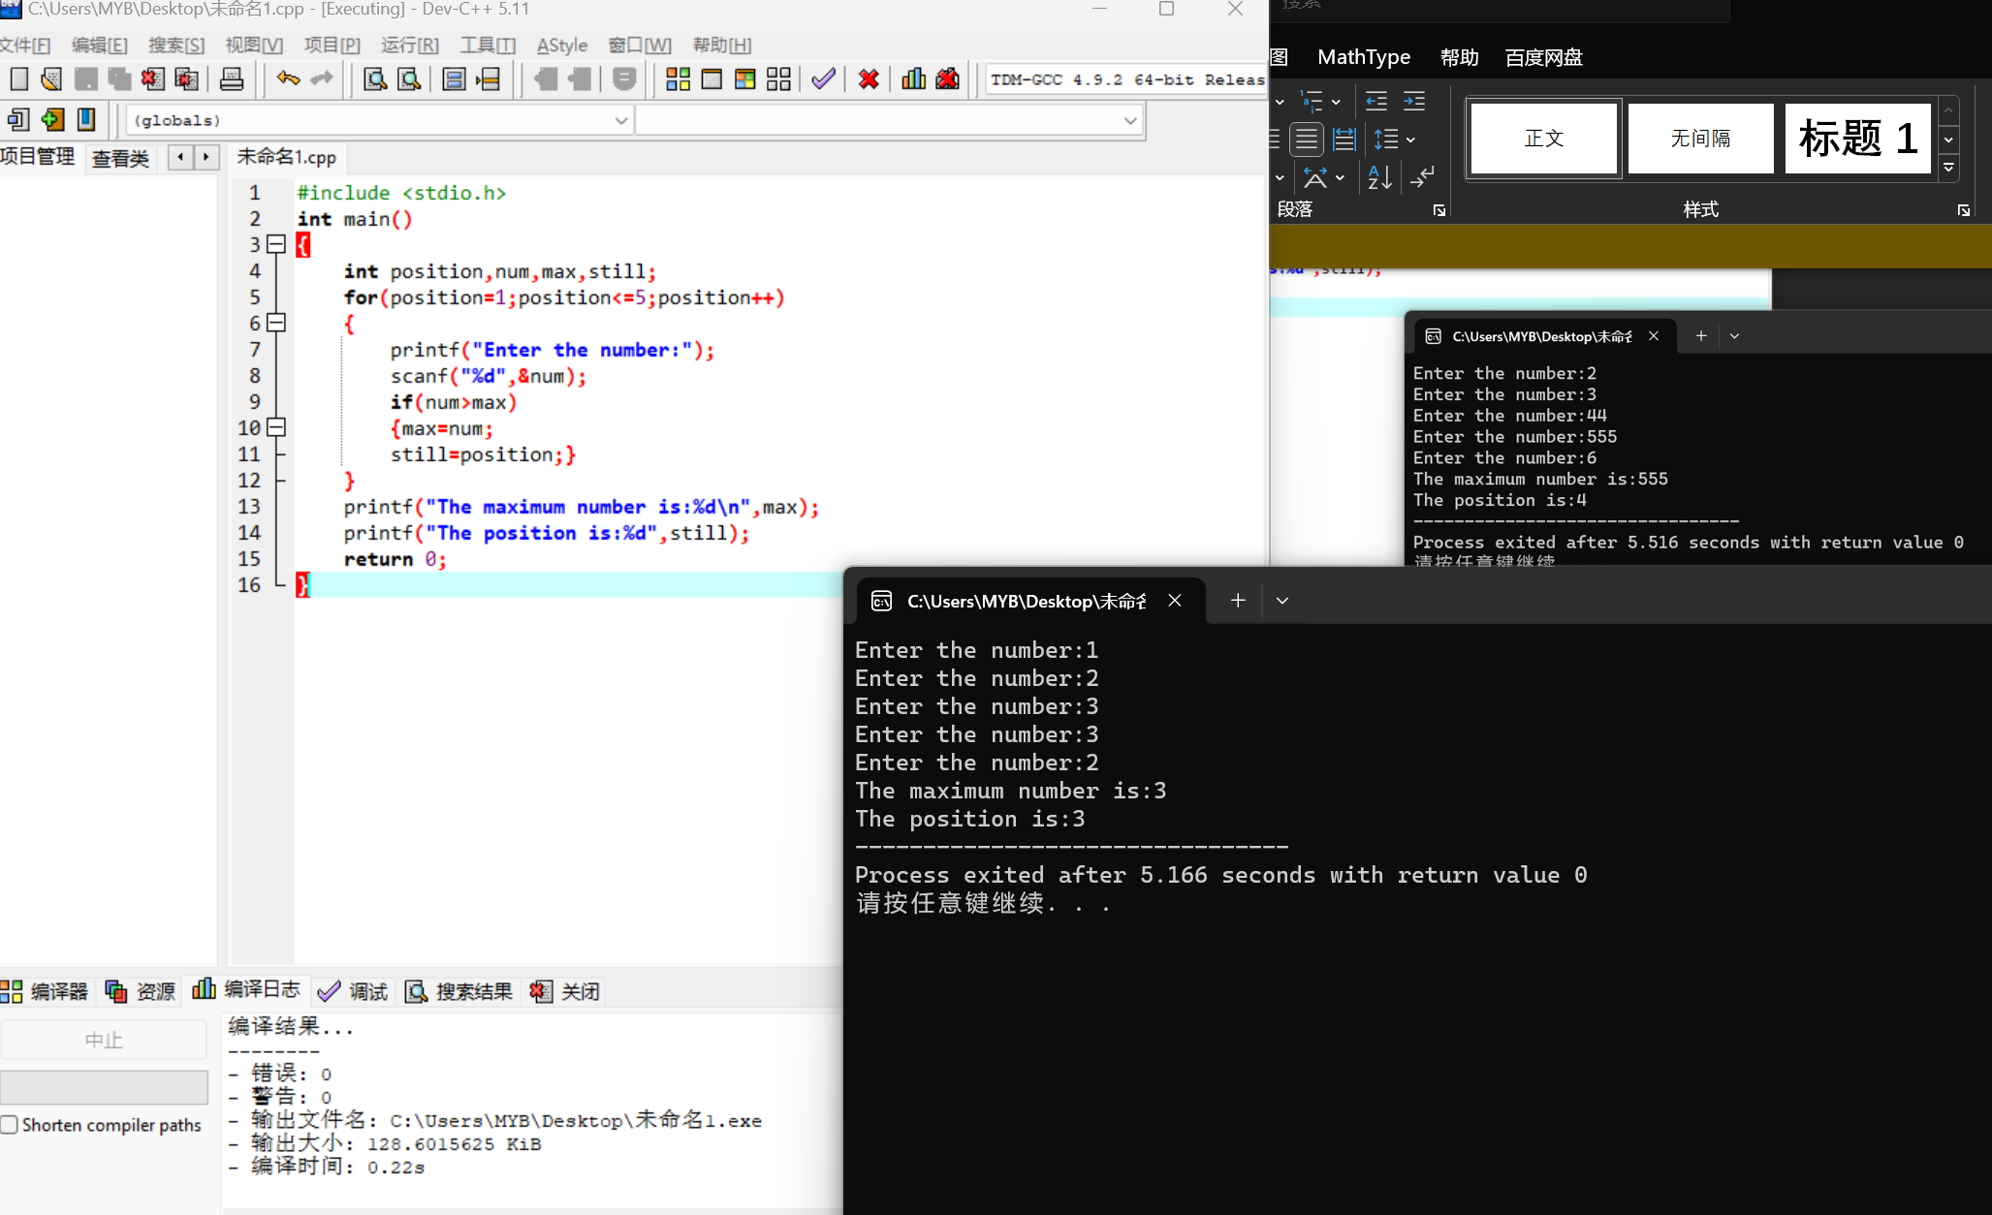

180.7

#include <stdio.h>

int main()

{

int num;

for (num=0;num<=20;num++)

{

if(num%3==0)

printf("The number:%d\n",num);

}

return 0;

}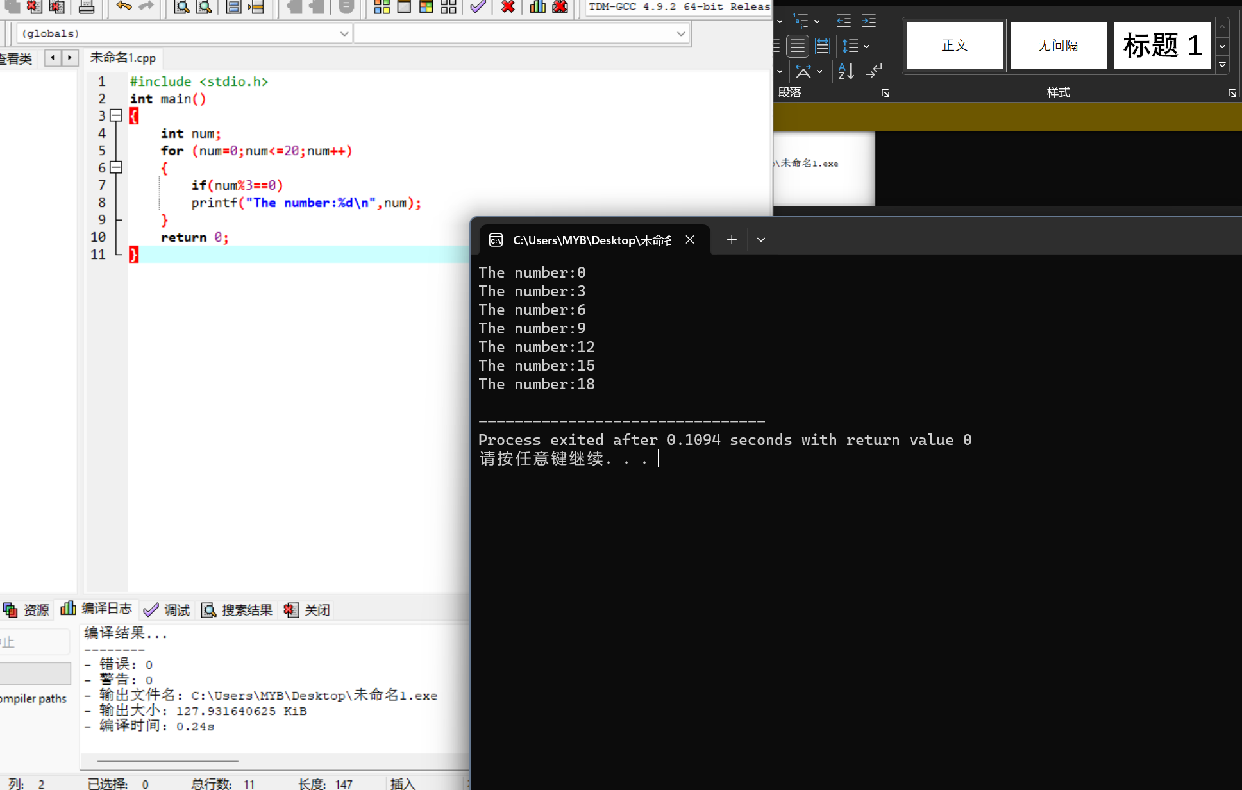

180.8

#include <stdio.h>

int main()

{

int age=12,amount,total;

for(amount=10;amount<=1000;amount=amount\*2)

{

total=amount+total;

age++;

}

total=total+amount;

printf("The age is:%d",age);

printf("\nTotal:%d",total);

return 0;

}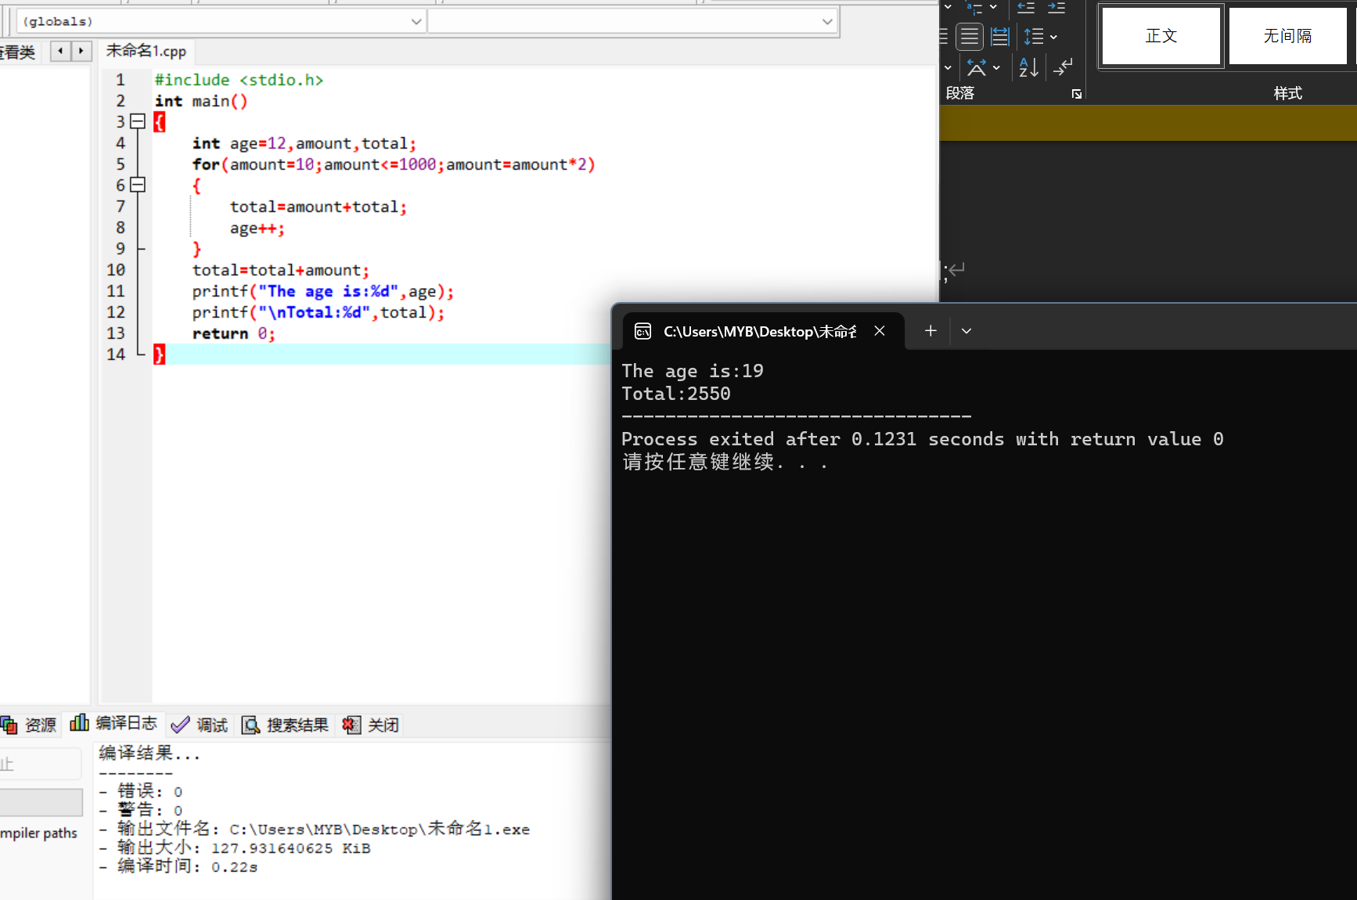

182.1

#include <stdio.h>

int main()

{

int num1,num2;

float test,ave,total;

for(num1=1;num1<=4;num1++)

{

total=0.0;

for(num2=1;num2<=6;num2++)

{

printf("\nEnter the value:");

scanf("%f",&test);

total+=test;

}

ave=total/6;

printf("\nThe average of no.%d is:%f",num1,ave);

}

return 0;

}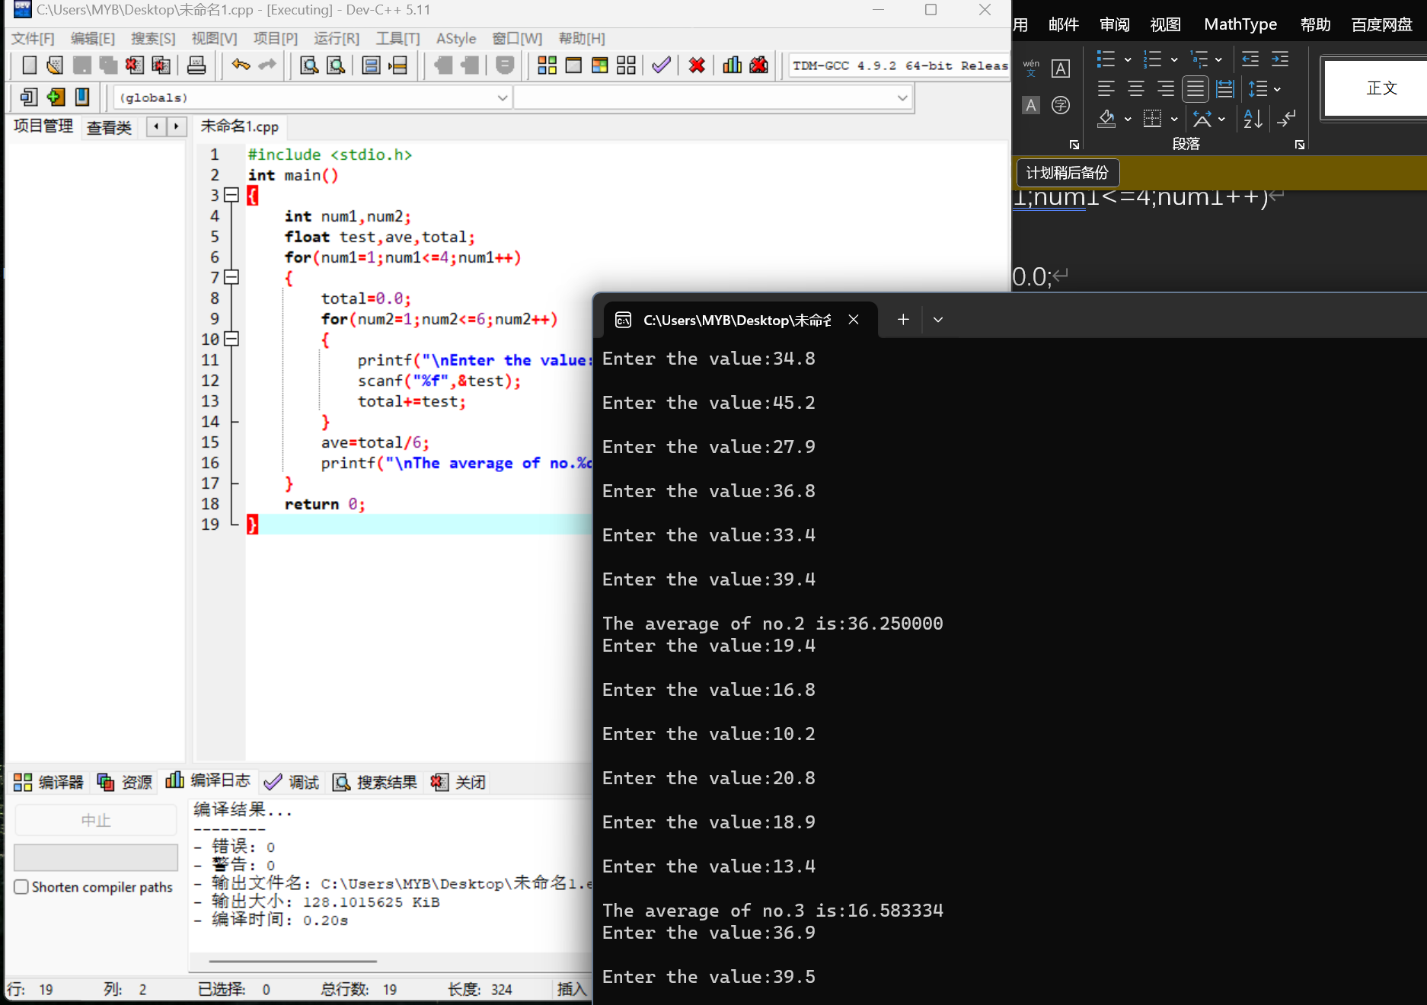

183.3

#include <stdio.h>

int main()

{

int num1,num2,score,total;

float ave;

for(num1=1;num1<=5;num1++)

{

total=0.0;

for(num2=1;num2<=3;num2++)

{

printf("\nEnter the score:");

scanf("%d",&score);

total+=score;

}

ave=total/3.0;

printf("\nThe bowler's average score is:%.2f",ave);

}

return 0;

}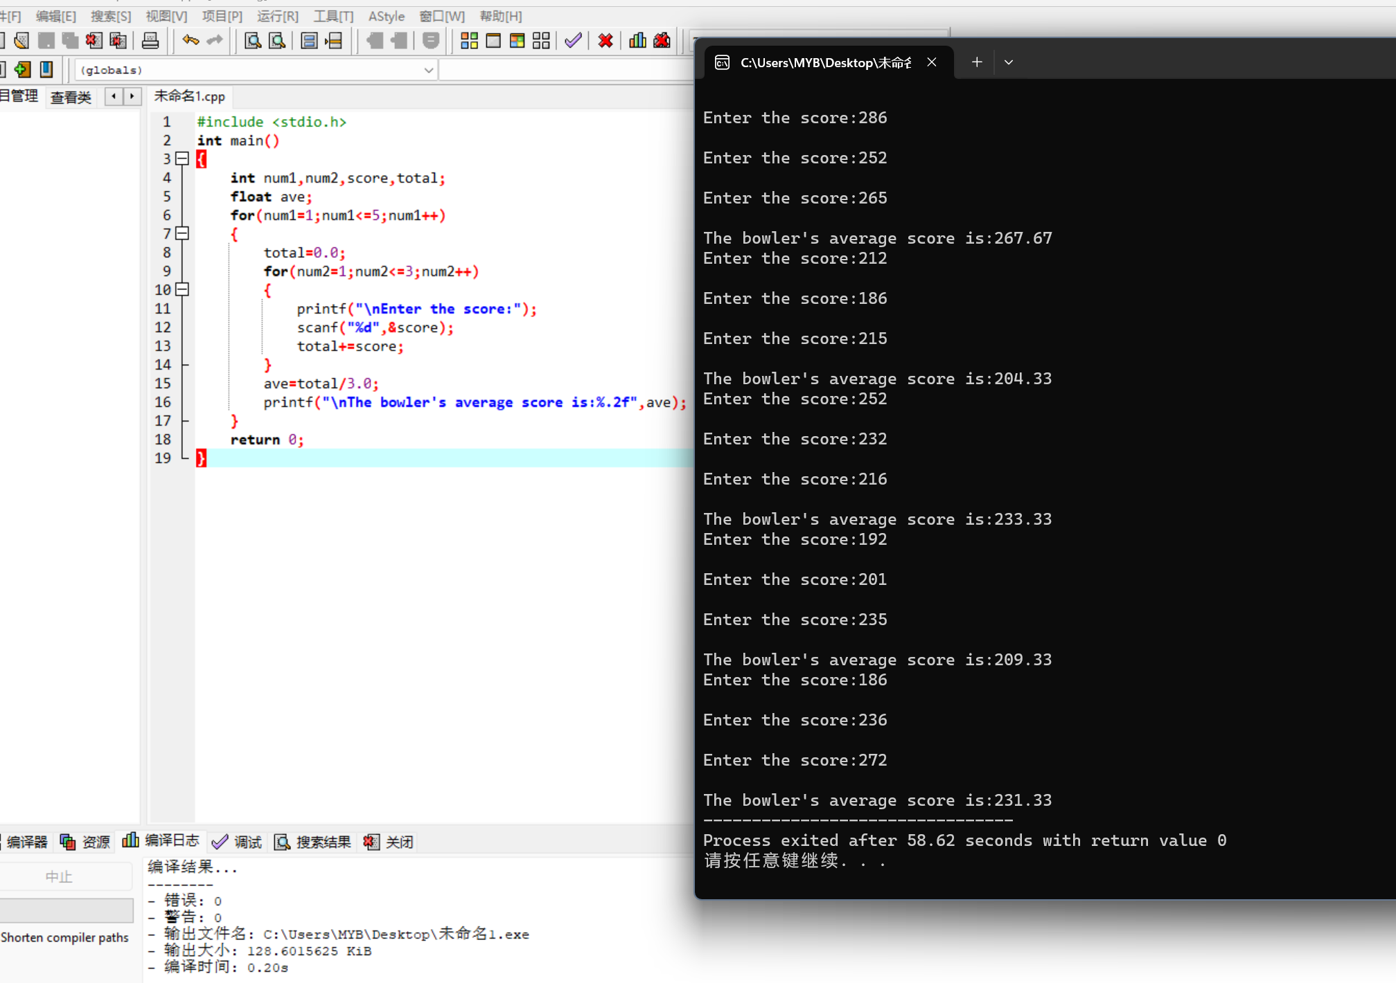

186.2

#include <stdio.h>

int main()

{

int grade,total;

float ave,count=0.0;

do

{

printf("Enter a grade:");

scanf("%d",&grade);

if(grade>100||grade<0)

{printf("This is an invalid grade!");

continue;}

else

{count++;

total+=grade;}

}

while(grade!=999);

ave=total/count;

printf("Average is:%f",ave);

return 0;

}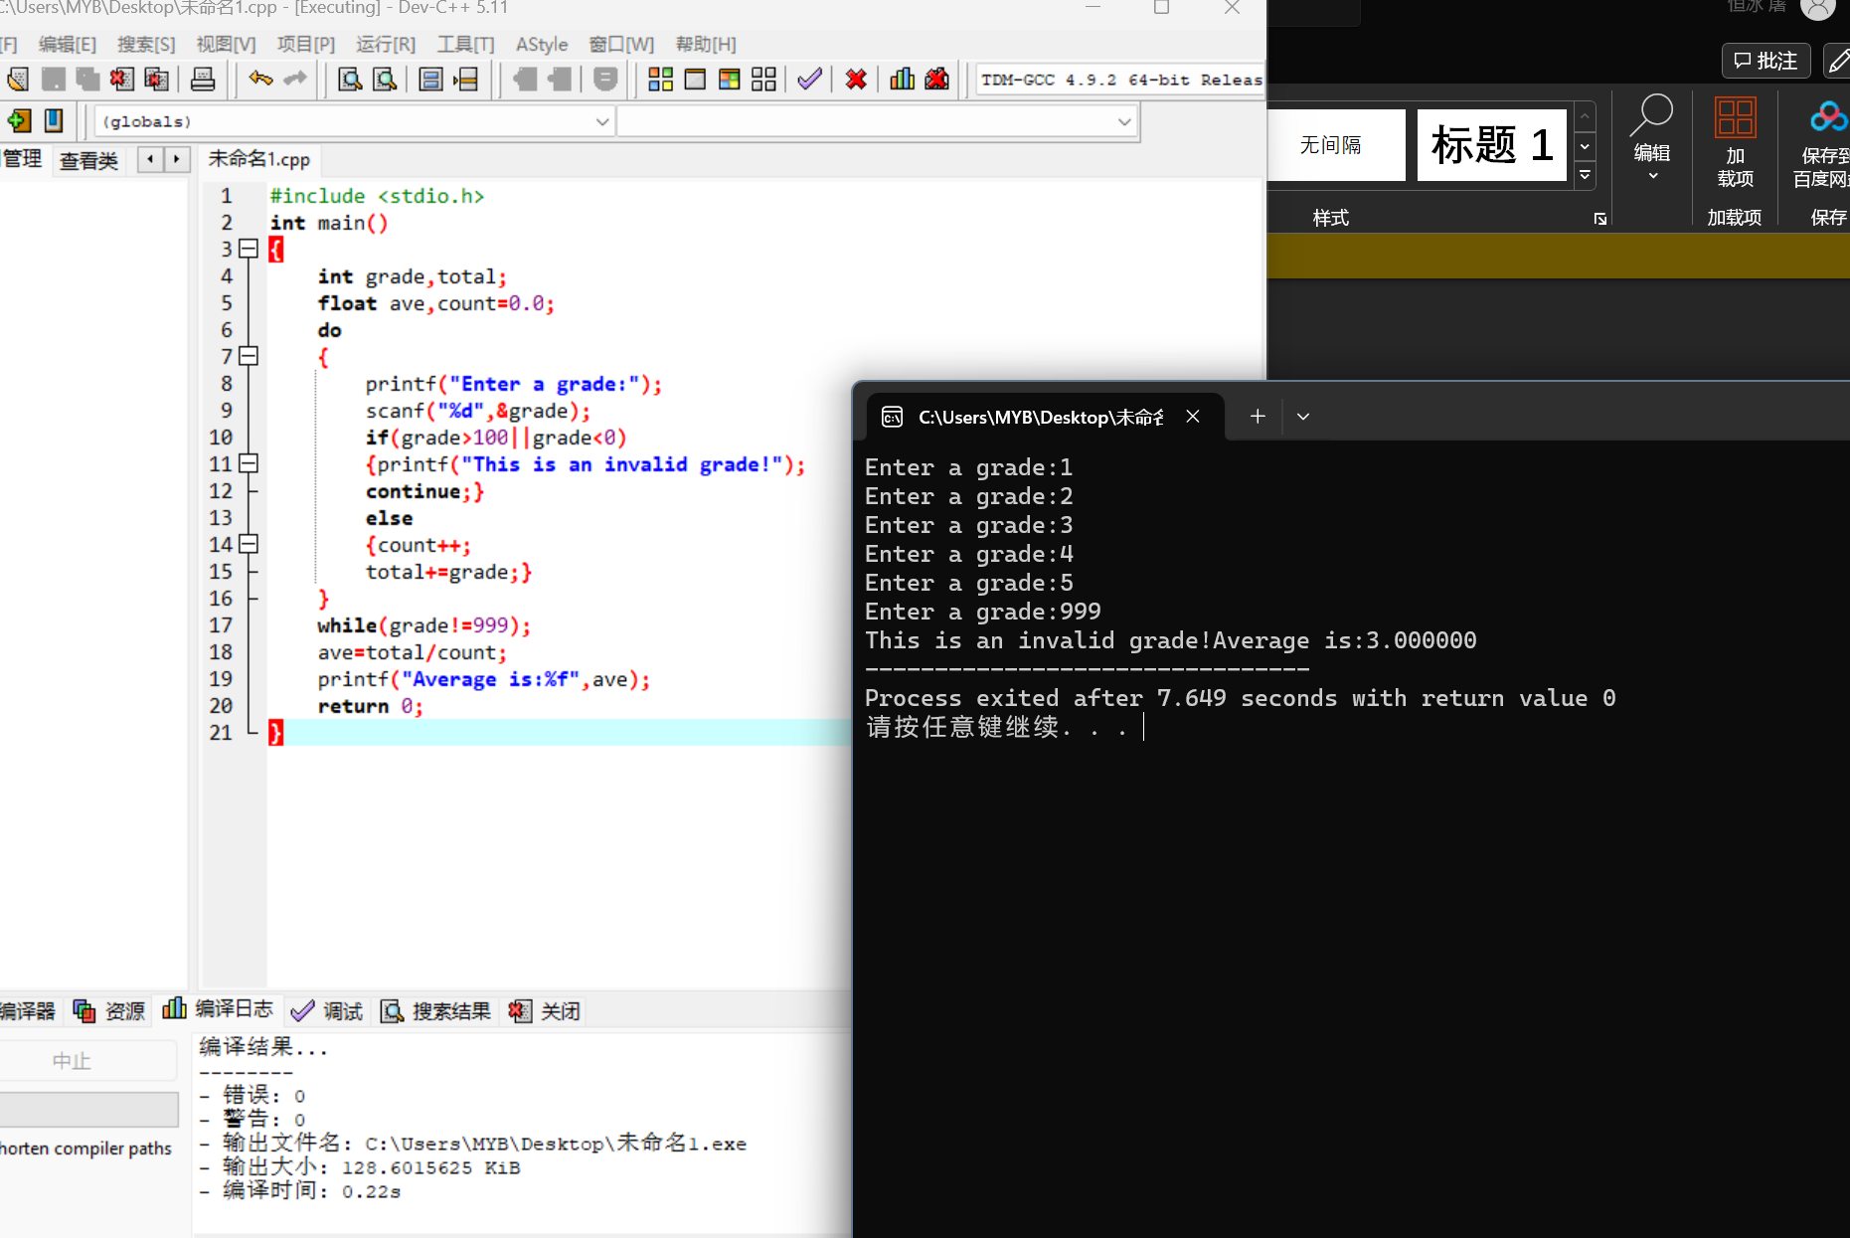

186.3

#include <stdio.h>

#include <math.h>

int main()

{

int num,a,count=0,r;

printf("Enter a number:");

scanf("%d",&num);

while(num!=0)

do

{

a=num%10;

num=num/10;

r=r\*10+a;

}

while(num!=0);

printf("Reverse:%d",r);

return 0;

}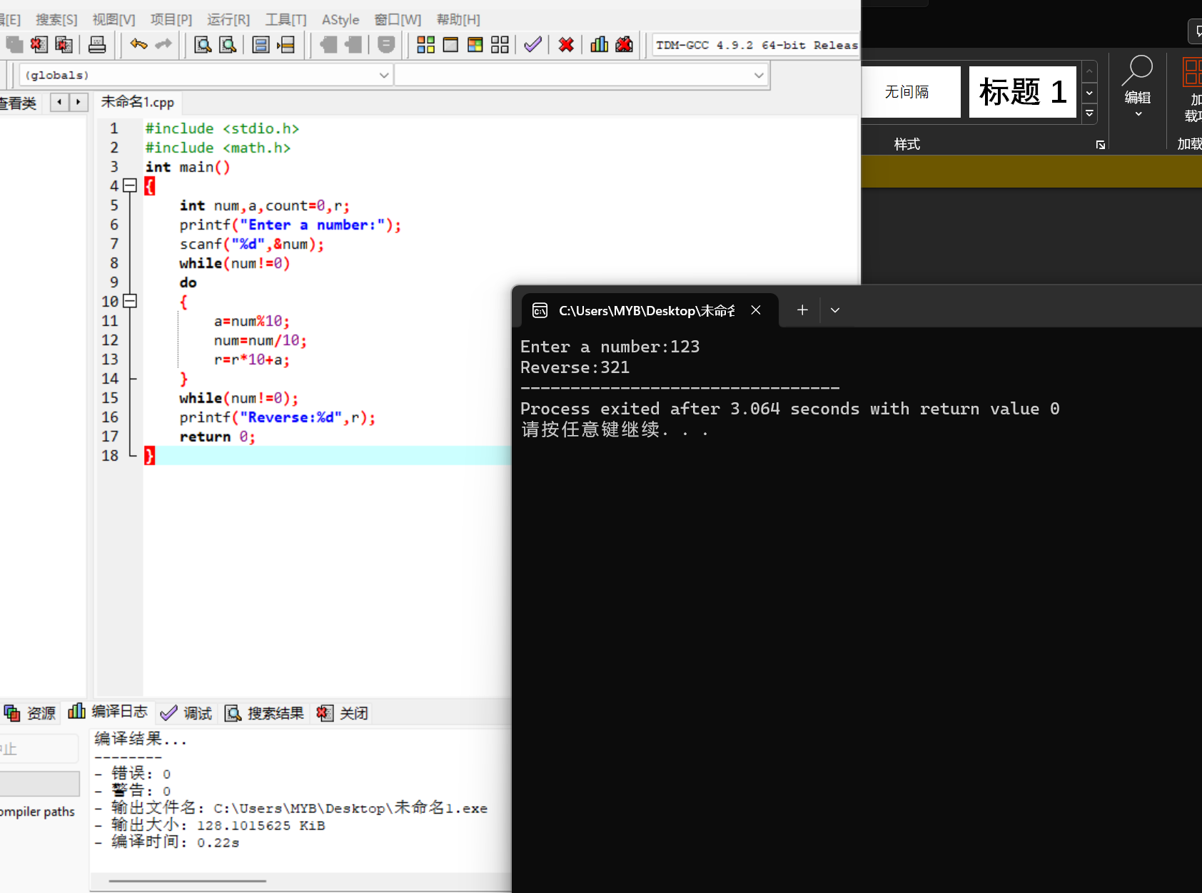

186.4

#include <stdio.h>

int main()

{

char c1,c2;

printf("Enter the first character:");

scanf("%c",&c1);

printf("\nEnter the second character:");

scanf("\n%c",&c2);

while(c1>=c2)

{printf("\nPlease enter the second character later than the first one!");

printf("\nEnter the first character:");

scanf("\n%c",&c1);

printf("\nEnter the second character:");

scanf("\n%c",&c2);}

do

{

printf("\nCharacter:%c",c1);

printf("\nDecimal:%d",c1);

printf("\nOctal:%o",c1);

printf("\nHexadecimal:%ox",c1);

printf("\n---------");

c1++;

}while(c1<=c2);

return 0;

}